Girl Scouts of Southwest Texas
Flag Day Patch Contest Entry Form
The Flag Day Patch Contest is held annually to adopt the design to be used to create the commemorative patch for the Catholic Life Insurance “Flag Day Celebration” event. Girls create a patriotic design using up to six (6) colors and submit it to the Resource Center. Entries are displayed at Catholic Life Insurance and one is chosen to be made into the event patch. Bring your entry to the resource center or mail them to:
Girl Scouts of Southwest Texas
Attn: Resource Center
P.O. Box 790339
San Antonio, Texas 78279-0339
Contest Guidelines:
- This contest is open to all registered Girl Scouts 5-17 years of age.
- Keep the design within the borders of the box below.
- Drawing may be horizontal or vertical and should be submitted in color. Use up to six (6) colors.
- In order to be displayed and/or considered for the event patch, the Parent/Guardian Permission and Release must be signed for each entry. Entries without parent/guardian signature will not be displayed.
- Deadline for entry is April 5, 2018. Entries will be displayed at Catholic Life Insurance, 1635 NE Loop 410.
- This year’s theme: What the American Flag means to me? Patch designs should include a drawing/image of the American Flag.

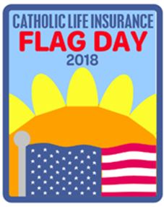
Winning Design: Flag Day 2018
Ava Jacobs, Troop 2346

Please note: The winning original design may need to be altered to adhere to guidelines set by our graphic designer.
Girl Name___________________________________________Troop #_________Service Unit______________________
Age level (circle one): Daisy (K & 1) Brownie (2 & 3) Junior (4 & 5) Cadette (6, 7 & 8) Senior (9 & 10) Ambassador (11 & 12)
Address_____________________________________________________________________________________________________
Parent/Guardian Name_________________________________________________________________________________________
Phone ( )______________________________________________ Phone ( )________________________________________
Email____________________________________________________
Parent Permission/Release: Catholic Life Insurance (CLI) and Girl Scouts of Southwest Texas (GSSWT) have my permission to display the above patch design created by my daughter (named above). In the event that my daughter’s entry is chosen, I give permission for it to be made into a patch to represent the annual CLI/GSSWT Flag Day event in June. I understand the patches will be distributed as CLI/GSSWT deems necessary.

Parent/Guardian Signature______________________________________________ Date________________________________

